Detection of hydrogen isotopes in fusion-relevant targets via laser ablation and microwave-induced plasma

Nikola Vujadinović1, Ivan Traparić1, Jovan Ciganović2, Alexandru Anghel3, Corneliu Porosnicu3*, Milivoje Ivković1

*1Institute of Physics Belgrade - National Institute of the Republic of Serbia, Pregrevica 118, Belgrade, 11080, Serbia*

*2Vinca Institute of Nuclear Sciences-National Institute of the Republic of Serbia, University of Belgrade, Mike Petrovića Alasa 12-14, 11351 Belgrade, Serbia*

*3National Institute for Laser, Plasma and Radiation Physics, 77125, Magurele, Bucharest, Romania*

*\*Corresponding author: corneliu.porosnicu@inflpr.ro*

**Abstract.** The analysis of plasma facing components (PFCs) of fusion machines using laser-induced breakdown spectroscopy (LIBS) technique is widely distributed in the fusion community. Difficulties arise when the spectroscopic measurements of tritium retention are performed, particularly the resolving of deuterium (Dα) and tritium (Tα) Balmer alpha lines becomes a major issue.

This study explores using microwave-induced plasma (MIP) generated in a custom-designed low-pressure chamber as a potential solution to this problem. The target material is introduced into the MIP via laser ablation using Nd:YAG laser, and the spectral signal is monitored with a high-resolution spectrometer and an ICCD camera. Two silicon-based targets were utilized: the first, coated with carbon (C) and methane (CH4), was used for optimization of the measurement system, whereas the second, coated with C and D, was used for final measurements.

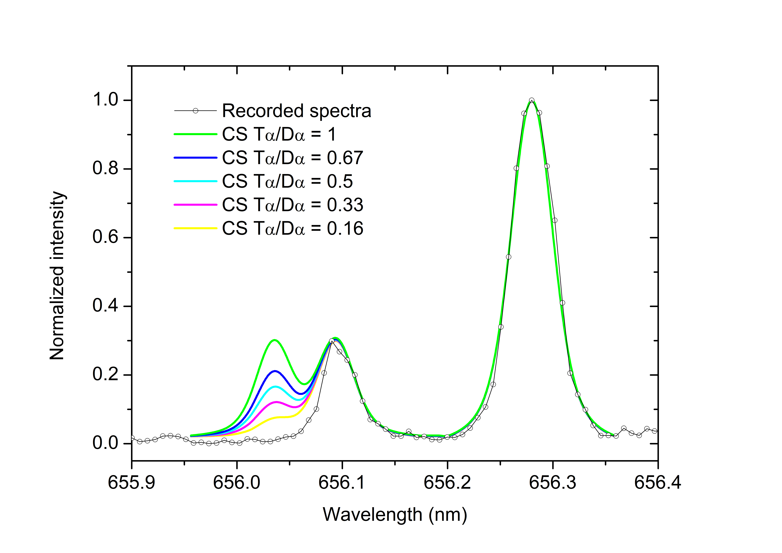As part of the optimization process, the optimal time window for signal recording was determined relative to the laser Q-switch trigger. Additionally, crater profiles were analyzed using an optical profilometer, yielding the estimated ablation rate of approximately 400 nm per laser pulse at a fluence of 5.4 J/cm2.

The final measurements indicate that, with the current setup, the lowest detectable tritium level would correspond to a Tα line intensity between 30% and 50% of the Dα line intensity (Fig. 1). These results show that this MIP-based setup is a promising tool for such analyses, providing reliable and fast determination of tritium content retained in fusion-relevant materials.

Figure 1. CS theory estimation of Tα resolving.